Project 1: Reference Architecture Ownership (Hub-and-Spoke with Transit Gateway)
AWS has many accounts and many VPCs (private networks). If every team connects them in its own way, the network turns into a tangle. This project gives everyone one standard design to copy: a hub in the middle and spokes around it.
- Hub: the Transit Gateway (TGW), a central router in AWS.
- Spokes: the VPCs. Each app or team plugs into the hub once.
- Why it helps: traffic between spokes passes through one place, so rules, logging and inspection are easy.
- Your job: own the blueprint, the IP address plan, the routing rules, and the guide on when to use TGW, Peering or PrivateLink.

Network diagram
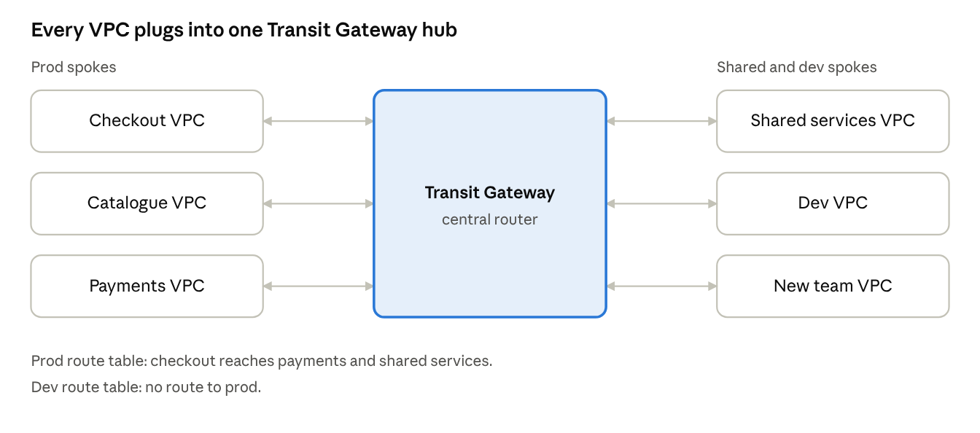
hub-and-spoke · 1 Transit Gateway, 6 VPCs
Every VPC connects to the Transit Gateway once. The route tables on the hub decide who can talk to whom.

When to use TGW, Peering or PrivateLink
Option | Use it when | Avoid it when
Transit Gateway | Many VPCs or accounts must talk to each other or to on-premises. | You only connect two VPCs.
VPC Peering | Two VPCs need a simple, direct link. | You have many VPCs: links multiply and routes become hard to manage.
PrivateLink | You share one service privately without opening the whole network. | Apps need full two-way network access to each other.

Standards this project owns
The values below are examples only; the team sets the real address plan.
Standard | In simple words | Example
CIDR plan | Every VPC gets its own IP range. No two ranges overlap. | Prod VPCs from 10.10.0.0/16, dev from 10.20.0.0/16
Subnet model | Every VPC uses the same subnet layout in each Availability Zone. | App, data, and a small TGW attachment subnet
Routing | Separate TGW route tables for each type of traffic. | Prod, non-prod, shared services, inspection
Segmentation | Prod cannot reach dev unless a rule allows it. | Prod route table has no route to dev

Production use case
Example scenario: a retail company runs its online store in AWS across many accounts. Checkout, catalogue and payments each live in their own VPC. A shared-services VPC holds logging and monitoring.
- Each VPC attaches to one Transit Gateway.
- The prod route table lets checkout reach payments and shared services.
- The dev route table has no route to prod, so a test mistake cannot touch customers.
- When a new team joins, they copy the blueprint and get a non-overlapping IP range. No redesign is needed.
Result: every new app connects the same way, and an audit can see exactly which VPCs can talk to which.

Interview questions and answers
Practice questions at the depth that senior cloud-network interviews at companies like AWS, Google and Meta expect. They are not official lists.
Q1. Design the network for 200 AWS accounts across 3 Regions.
Give each workload its own account and VPC. Use one Transit Gateway per Region and peer them between Regions. Keep separate TGW route tables for prod, non-prod, shared services and inspection. Plan IP ranges centrally (for example with VPC IPAM) so none overlap. Share the TGW with AWS Resource Access Manager, build everything with IaC, and monitor with flow logs.
Q2. When do you choose Transit Gateway, VPC Peering or PrivateLink?
Transit Gateway fits many VPCs and on-premises links. Peering fits two VPCs that need a simple direct link. PrivateLink fits sharing one service without opening the whole network, and it works even when IP ranges overlap. Peering links multiply as VPCs grow, which is why it does not scale.
Q3. Two teams already use the same CIDR. What do you do?
TGW cannot route between overlapping ranges. Best fix: re-address one VPC. If that is not possible, expose only the needed service with PrivateLink, or use a private NAT gateway to translate. Then add IPAM so it cannot happen again.
Q4. How do you keep prod and dev apart on one Transit Gateway?
Use separate route tables. Associate prod attachments with the prod table and dev attachments with the dev table. Propagate only the routes each side should see, and add blackhole routes for anything that must never connect. Test with Reachability Analyzer.
Q5. How does your design survive an Availability Zone failure?
Create TGW attachments in subnets in more than one AZ. Run workloads in several AZs. If you add firewalls, turn on appliance mode so both directions of a flow stay in the same AZ. Practise failure tests before relying on it.
Q6. What limits Transit Gateway at scale, and how do you plan for it?
Quotas apply to attachments, routes per route table and bandwidth per attachment. Plan with summarized routes instead of many small ones, watch usage with CloudWatch metrics, and request quota increases early. Check the current AWS quotas page, because limits change.

